

2026 ANNUAL REPORT
September 2026

Castle Rock Renewal facilitates investment and redevelopment of blighted areas within the Town of Castle Rock. We work in partnership with the Castle Rock Economic Development Council to help make projects financially feasible and buildable. Sustainable development in underutilized areas of our community enhances our tax base and creates new jobs and amenities.

Contact us:
100 N. Wilcox Street
Castle Rock, CO 80104
720-733-3519

www.castlerockrenewal.org

CRURA Commissioners CRURA Staff
Jason Gray, Chair Pete Mangers, Executive Director
Kevin Bracken Michael J. Hyman, Legal Counsel
Mark Davis Trish Muller, Treasurer
Laura Cavey, Vice Chair Lisa Anderson, Clerk
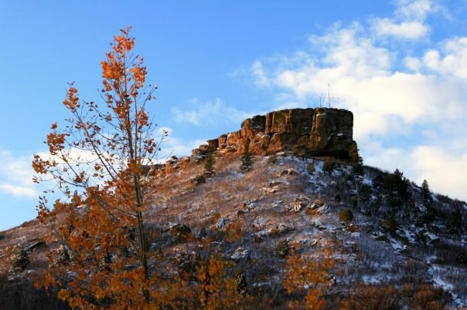
Max Brooks
Ryan Hollingshead
Tim Dietz
George Teal
Kyrzia Parker
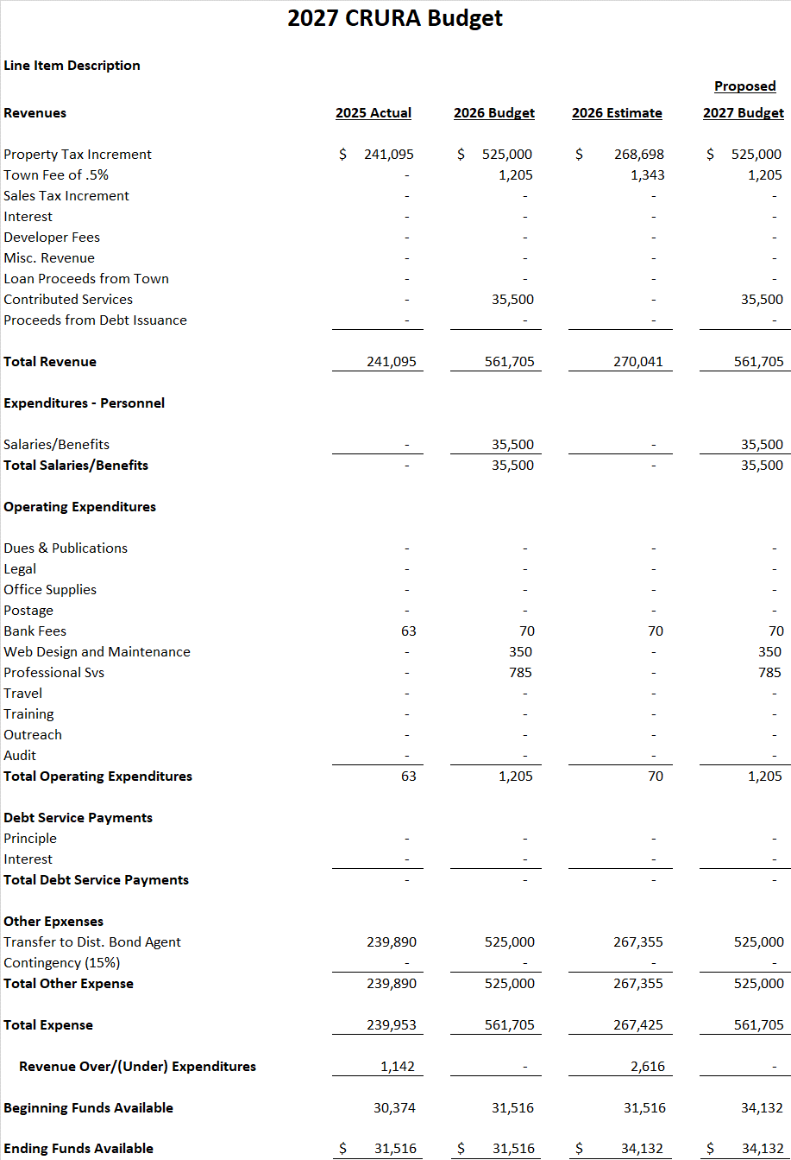
Citadel Station (Millers Landing) Urban Renewal Plan
Plan Highlights -

- Located at the NW intersection of Interstate 25 and Plum Creek Pkwy, bounded by Plum Creek Pkwy on the south, I-25 on the east, and the Castle Highlands Industrial Park on the north.

• Comprised of 3 privately owned legal parcels totaling approx. 65.9 acres within the Town boundary.

• To reduce, eliminate and prevent the spread of blight, the goal of the Plan is to remediate the abandoned municipal dump site and abandoned clay mines located on the site and stimulate growth and investment in the area.
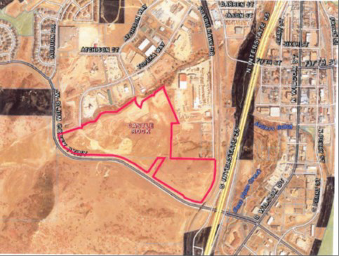

Brickyard Urban Renewal Plan
Plan Highlights –
On February 18, 2025, Castle Rock Town Council approved the Brickyard Planned Development (PD) Plan. This PD Plan allows for a mixed-use redevelopment of the property, with a maximum of 583 multi-family dwelling units consisting of townhomes and apartments, 92,000 square feet (sf) of non-residential uses such as office, retail, restaurant, up to 145,000 sf of sports development/recreational uses, and a 99,000 sf, 125 room hotel with a conference center and an outdoor performance venue.

